# Notes on Wiring the G320 and Mach 3

**Mariss**

1. COMMON on the G201, G202 and G320 goes to +5VDC on your breakout board. For all these drives, if you are using Mach3 as your CNC program, set STEP to 'ACTIVE LOW' in 'ports and pins', set STEP PULSE WIDTH to '2 microseconds' in 'motor tuning'.

**IH Optical Limit Wiring**

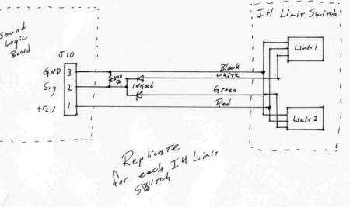

Try a 330 ohm instead of the 270 ohm if this doesn’t work!

**VFD Note by Tom Caudle**

If your VFD has a RUN logic signal (low current DC) you will have to use the Solid state relays to turn on a conventional dry contacts relay. Solid state relays won't work with logic level DC.

Computer power supplies typically have a common ground (chassis) and the safety ground of the AC.....That will tie everything together and defeat any optoisolation advantages for ground loop prevention or ground conducted noise issues.   
  
The whole grounding thing gets confusing because no two grounds more than a few inches apart are at the same potential. (ground is not Ground!) The more current there is between the systems and the higher the frequencies the more pronounced the difference. For logic level circuits a volt or two of noise can produce unwanted effects.  
  
  
Two opto isolated systems must have separate power supplies that do not share the same ground (common). The whole point of the isolation is have the "galvanically" isolated.....no chance for current to flow for any reason.  
  
Since the Campbell card comes with two separate supplies on the card and they are already hooked to the right place all that issue is resolved.  
  
I am not a big fan of triac based (solid state) relays unless you KNOW what the load is going to be. Highly inductive loads can cause triac misfires and jittery operation. That noise can be reflected back into the AC line. They don't work with softstart router controls or DC anything...including logic to VFD's or a plasma torch on signal. Conventional electromechanical relays are more reliable in a world where you never know what will be hooked to them.  
  
Speed controls made for routers use the fact that a universal motor's RPM is proportional to the applied voltage....unfortunately so is the torque. The same is true for DC motors. At a given voltage when you load them the RPM drops. Unless you have some form of torque feedback from the motor maintaining anything close to a constant speed with a simple phase controller is impossible. As you crank down the RPM it's more pronounced. Constant RPM with an AC speed control is fairly straighforward. For a DC motor it's more difficult.  
  
Sometimes the devil is in the details. Just adding components to a board does not always solve the problem....than takes engineering.